**Earth Science Learning Targets**

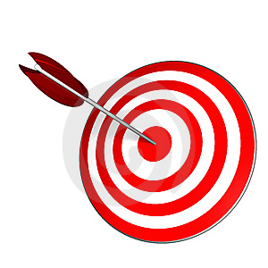**Unit: Matter and Measurement**

*The following is a list of the things you will know and be able to do when you are finished with the Matter and Measurement Unit.*

**\* = M&M (MUST Master at 80%)**

|  |  |  |  |  |
| --- | --- | --- | --- | --- |
|  | **Learning Target** | **Essential Vocabulary** | Formative Quiz Score | What did you do After Quiz? |
| **0** | I can set up a scientific investigation and analyze the data collected to draw conclusions. |  |  |  |
| **\*1** | I can use a triple beam balance, graduated cylinder, and a ruler to collect data. | **Pretest Scores:**  Length:  Liquid Volume:  Mass:  Solid Volume:  Temp.:  Converting: |  |  |
| **\*2** | I can make a data table and a line graph. |  |  |  |
| **3** | I can find the density of an object using its mass and volume. | * Mass * Volume * Density * Displacement Method |  |  |
| **\*4** | I can explain a physical change and use evidence to identify a physical change. | * Physical change * Physical property * Phase * Conservation of mass * Dissolving * Melting point * Boiling point * Freezing point * Open System * Closed System |  |  |
| **\*5** | I can explain a chemical change and use evidence to identify a chemical change. | * Chemical change * Chemical property * Chemical reaction * Chemical equation * Reactant * Product |  |  |
| **6** | I can explain the difference between pure substances and mixtures using physical properties. | * Solubility * Pure substances * Mixture |  |  |
| **\*7** | I can explain the differences between elements and compounds in terms of atoms and molecules. | * Atoms * Compounds * Molecules * Elements * Periodic Table of Elements |  |  |
| **8** | I can distinguish between acids and bases, and between metals and non-metals. | * Acids * Bases * Metals * Non-metals * Conductivity * Insulator * Conductor |  |  |

